
...Innovative liquid vaporizing and gas mixing solutions
Bulletin Number: DF 10/01
Thermostat Calibration
The following conditions may be an indication that your thermostat needs calibration:
- Main burner will not light
CAUTION: Vaporizer must have main burner shut off valve(A) installed prior to performing these procedures. If you do not have this valve, please contact your Algas-SDI dealer and ask for kit #40363.
- Vapor service pressure drops
- Unit not making rated capacity
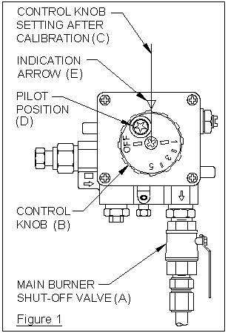
How to check if your thermostat needs calibration:

At each inspection, service interval, repair or commissioning of a new vaporizer, the thermostat calibration needs to be checked.

STEP 1:
This inspection must be done after the vaporizer is shut off and allowed to cool to surrounding temperature
(0°F to 75°F or -18°C to 24°C).

STEP 2:
Close main burner shut off valve (A).

STEP 3:
Rotate thermostat control knob (B) counter clockwise
until it stops at the 5 setting.

STEP 4:
Rotate control knob clockwise until there is a noticeable
click (stop rotating control knob at this point).

STEP 5:
Reference control knob position to (C) in figure 1. For correct setting, indicator arrow (E) needs to be pointing just after pilot button (D).
If thermostat control knob is at correct setting in step 5, no further steps are required. If setting is incorrect, continue to step 6.
1140 NW 46 Street, Seattle, Washington, USA 98107
Tel: 206-789-5410 Fax: 206-789-5414 Web: www.algas-sdi.com

Revision: November 20, 2002 FILE: Bulletin DF 10-01 Thermostat.doc
B/N: DF 10-01

...Innovative liquid vaporizing and gas mixing solutions

Bulletin Number: DF 10/01

Thermostat Calibration Continued

STEP 6:
To adjust calibration, remove control knob by removing screw, being careful not to rotate knob or thermostat control shaft.

STEP 7:
Replace control knob on thermostat control shaft with indicator arrow pointing just after pilot position and tighten screw(C). Reference control knob position in figure 1.

Thermostat is now calibrated-see owners manual for standard start-up procedures.

At Algas-SDI we are committed to continuous improvement and customer satisfaction. If you have any questions regarding this bulletin or have an improvement suggestion you would like to make, please write or phone Customer Service.
1140 NW 46 Street, Seattle, Washington, USA 98107
Tel: 206-789-5410 Fax: 206-789-5414 Web: www.algas-sdi.com

Revision: November 20, 2002 FILE: Bulletin DF 10-01 Thermostat.doc
B/N: DF 10-01

